Burbank Housing Downpayment Assistance Loan Program Summary (as of 6/2026)
INFORMATION FOR LENDERS PLEASE READ AND ACKNOWLEDGE THE FOLLOWING:
- BURBANK HOUSING MUST BE LISTED ON ALL HAZARD INSURANCE POLICIES FOR PROPERTIES INCLUDING HOA and HO6 POLICIES
- ALL FIRST LOANS MUST BE IMPOUNDED WITH 30-YEAR FIXED RATE FULLY AMORTIZED LOAN TERMS.
- PERMANENT RATE BUY DOWNS PERMITTED ON THE 1st CANNOT EXCEED 1% OF THE LOAN AMOUNT AND CANNOT BE PAID FOR WITH CALHOME FUNDING
- E-SIGNING IS NOT PERMISSIBLE ON LENDERS FINAL LOAN DOCUMENTS Lender initials: _______________

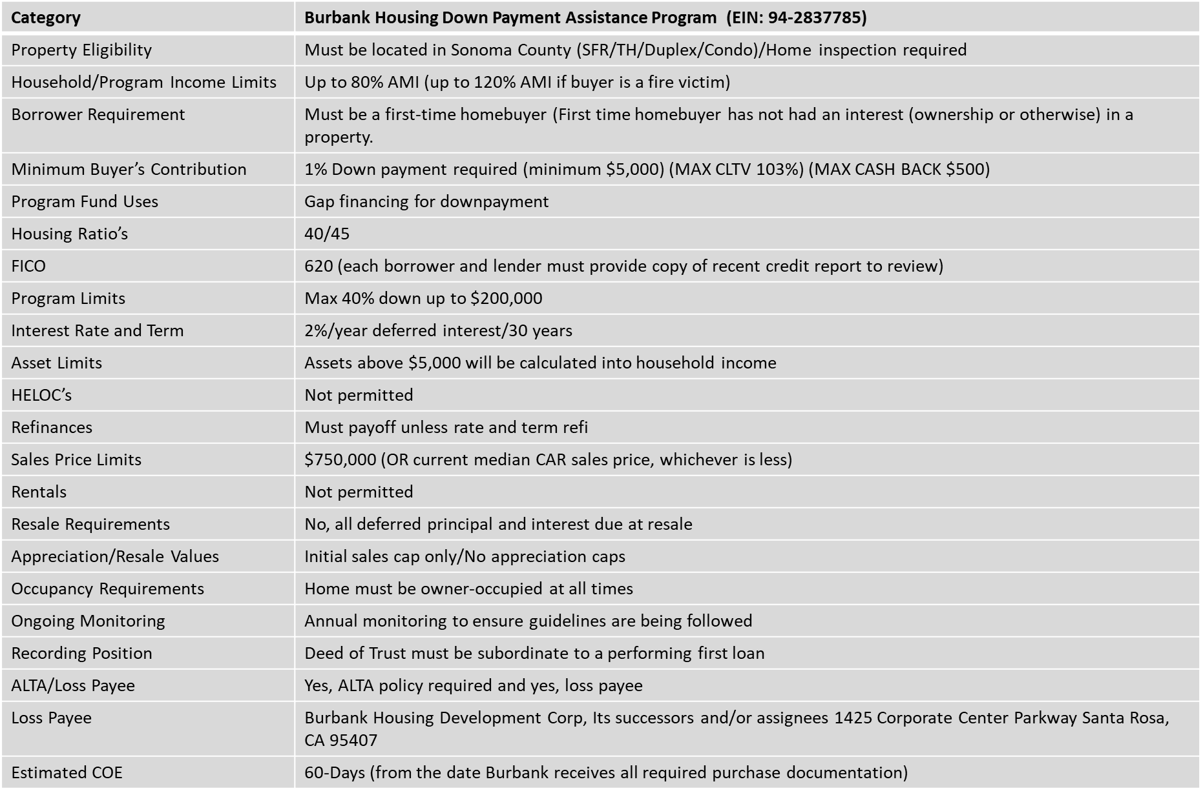

Sonoma County Maximum Income Limits 2026

*Must be a fire victim of a Sonoma County Wildfire. Fire victims include households who lost a home directly (or indirectly due to forced move due to the wildfires) or who experienced a 10% or more rent increase within 12 months of a fire. All property and purchase applications will be underwritten and approved by Burbank Housing for program eligibility.
Burbank Housing Lender Approval Certification
_____________________, Lender, acknowledges receipt of the Burbank Housing CalHOME Summary, as well as the CalHOME program documents including Program Guidelines, Promissory Note, Deed of Trust and PowerPoint https://www.burbankhousing.org/homeownership/downpayment/. ____________, Lender, confirms a thorough understanding of the program and certifies that its legal and/or underwriting department have approved the use of this loan program and can lend in conjunction with a Burbank Housing Downpayment Assistance Loan. _______________, Lender, understands that this program is a loan program and acknowledges the terms of the loan and program requirements. Furthermore, _______________, Lender, understands that any intentional approval of applications that do not meet the program requirements may impact the lender's ability to participate in the program in the future.
Authorized Lender Representative Signature:
________________________________________ Date:____________________________________

Print Name:______________________________

Title:____________________________________ Email:___________________________________

